(Approx. 1,274 words)

Image Processing Software, Part 3
By Dick Maybach, Member,
Brookdale Computer Users’ Group, NJ
April 2014 issue, BUG Bytes
www.bcug.com / n2nd (@) att.net

In the February and March 2014 Bytes (available at http://www.bcug.com/) I discussed basic image processing with free software, and in this article I'll cover two specialized techniques, panoramic and high dynamic range (HDR) images. Both involve combining several separate images into one.

Hugin (http://hugin.sourceforge.net/ available for Linux, OS X, and Windows) is my preferred tool for creating panoramas. The screen-shot shows two of the six frames that I stitched together to create a panorama. In previous screens, I selected the images and told Hugin to create control points (points in different images that should coincide on the panorama). These appear as crosses identified by numbers in squares. The table below the images shows the offset distances (in pixels) between the points when they are overlaid. The green bar above the images indicates that Hugin is happy with the alignment; however, I had to eliminate several points to get this approval. If the number had become too small, I could have added more by hand, but this is tedious and fortunately is seldom necessary.
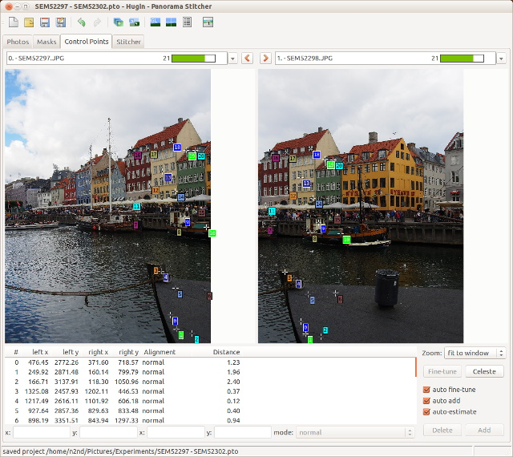

The resulting panorama appears below, although I adjusted the brightness and contrast with RawTherapee and GIMP after Hugin had finished with it. The Olympus bundled image processor also creates panoramas as do many modern cameras, but I find that often the results from Hugin are far superior. Hugin doesn't understand raw, so you must develop your images before using it. Although most panoramas are one-dimensional, that is composed of a single row of images, Hugin can create two dimensional ones, made from multiple rows of images. You also can choose from several different projections when creating the final image.
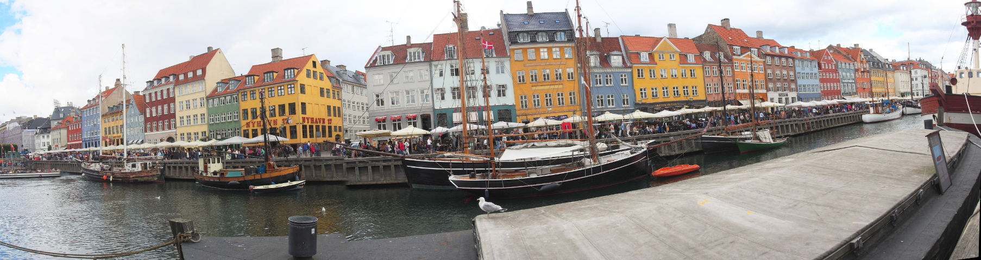

High Dynamic Range (HDR) photography attempts to overcome the dynamic range issue. You are probably disappointed with some of your pictures where the blue sky and white clouds have become a uniform pure white, and you can see nothing the shadows, which have become pure black. While recording in raw format can help some, it too has much less dynamic range than our eyes. The solution is to take several pictures of the same scene with different exposures. Some will have the highlights properly exposed (but the shadows will be black) and some will show what is in the shadows (but the highlights will be white). We then use clever software to combine these so that a single image shows both the highlights and the shadows. The problem is that there is no way to display the result, since the usual media (computer displays and paper prints) all have severely limited dynamic range. Thus we must perform tone mapping, which decreases the exposure of the highlights and increases that of the shadows and yet doesn't cause color shifts or other unpleasant effects. If done properly, the result is a low dynamic range image that looks close to what our eyes saw originally. If done improperly, the result can be a caricature, more artistic than realistic. Many modern cameras can perform HDR processing directly, but as with panoramas, adding human judgment to the process often greatly improves the result.
The screen-shot shows Luminance HDR (available for Linux, OS X, and Windows) working on a high-dynamic-range image, which was created by combining five raw images with different exposures (-2, -1, 0, +1, and +2 EV). The camera was hand-held, and the auto-alignment feature of Luminance was used to align them. Compare this to the LightZone screen-shot in my March 2014 article and you can see that the exposure of the room here is much better and that through the window is marginally so. (This isn't because of a shortcoming of LightZone, which after all had only a single image to work with.) More exposures covering a wider range than four f-stops would have produced a better image. As with LightZone, Luminance HDR has no provision for correcting distortion, so further processing with GIMP (or pre-processing with RawTherapee) is needed. Also, if you look carefully at the edges of the image, you can see where the images did not line up. Again, a light cropping with GIMP would remove this.
In some cases, I've found that although Luminance HDR uses the Hugin algorithm to align the input images, the alignment isn't that good. I can often do better by using Hugin to align the images and create a floating-point HDR file, which I then input to Luminance HDR for tone mapping. I assume this is because in Hugin I can optimize the control points, where using Luminance HDR everything is automatic.
The screen-shot shows the last step in the creation of the image. In previous screens I selected the files, let the program align them, and created a high-dynamic-range image. This screen shows the tone mapping, where the dynamic range is compressed so that it can be displayed using a low-dynamic-range medium such as a display or a print. The thumbnails along the right allow selection of the mapping algorithm, and each has a different set of controls, shown on the left. Drago processing, shown here, has only two parameters, which makes is quick to adjust. The strength and the weakness of Luminance HDR is the freedom to choose from eight algorithms and your control over the parameters of each. Knowing the best algorithm for each image and developing a feel for how the parameters affect the tone mapping takes a good bit of experience. Those used to the hand-holding provided by commercial software will find their initial experiences frustrating.

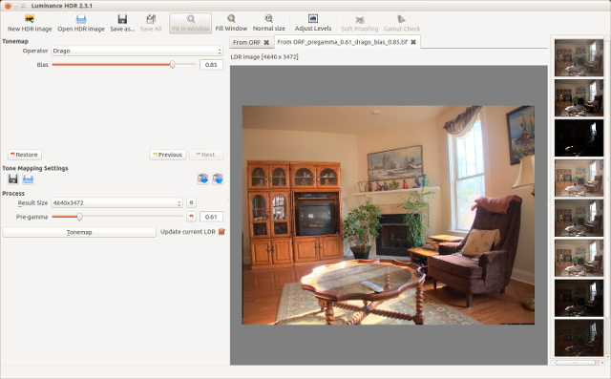

HDR photography is tricky and tedious, and works only in special cases. For example, outdoor pictures with large areas of foliage in the foreground are seldom satisfactory, because the leaves are always being blown about, and this makes it impossible to align the individual images. Luminance HDR has an anti-ghosting feature to overcome this problem, but it works best when the motion is confined to a small area. If you think you have a situation that calls for this technique, go ahead and take your pictures with their bracketed exposures. Before you start the HDR process though, select just one or these images and develop it carefully with the tone-mapping features of RawTherapee or LightZone. I often find that the result is just fine.

Expect some frustration from your first digital image processing efforts. It was a big day for me when I could consistently obtain results that were as good as the JPEG images straight from the camera. I find it helpful to display a camera JPEG image to which I can compare the one on which I'm working. It's easy to go seriously wrong, one small logical step at a time, if you work without a reference.

References:
- Montabone: Beginning Digital Image processing Using Free Tools for Photographers, which I referenced in the previous article, also discusses Hugin and Luminance HDR. He refers to the latter by its original name, qtpfsqui.
- http://www.cambridgeincolour.com/ – contains many very valuable tutorials on photography and image processing. I also referenced this in the previous article, but I mention it again because it includes HDR and panoramic techniques.
- http://hugin.sourceforge.net/tutorials/index.shtml – has several tutorials on using Hugin.
- Bloch: The HDRI Handbook 2.0 – is comprehensive discussion of HDRI theory and processing, geared toward commercial software and includes a DVD with free and trial commercial software. The author does not care for Luminance HDR, but he is a professional for whom throughput is more important than cost.
- http://blog.patdavid.net/2013/05/hdr-photography-with-foss-tools.html – is a very helpful guide to the tone mapping tools in Luminance HDR.
- “HDRI Photography” at http://www.makeuseof.com/pages/download – is a good introduction to the topic and to Luminance HDR

